Constructing Line

Definition
# Source: AI Source: Provided by: [Data Path: Persons Table -> ID Column: 1, Name_En Column: Motasem Essam] -> From: [ChatGPT] on [7/25/2026]
Constructing a Line is the geometric construction of a straight line determined by two distinct points and extending infinitely in both directions.
A line passing through points $A$and $B$is written as:
$$\boxed{\overset{↔}{AB}}$$
A line has no endpoints and extends indefinitely in both directions.
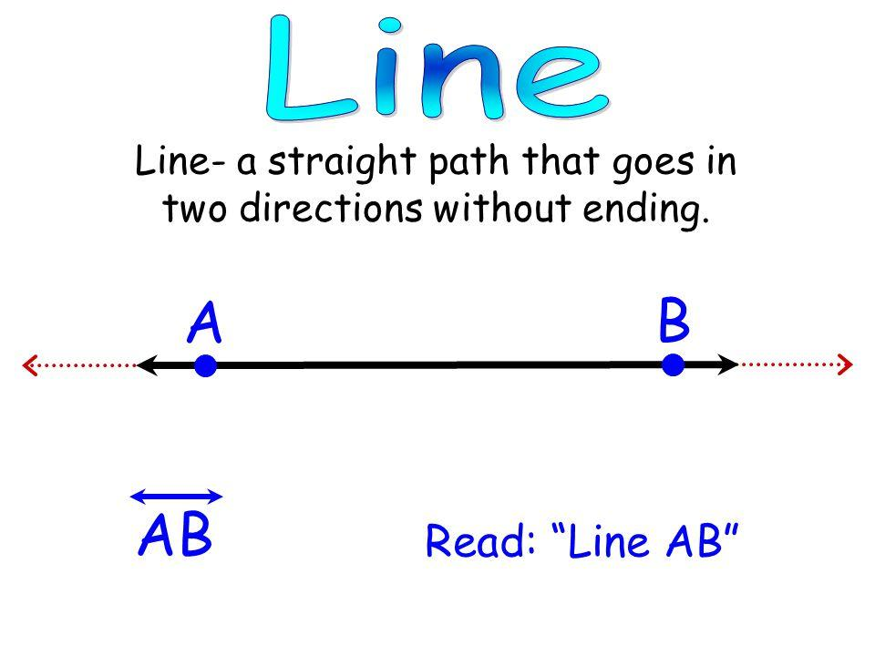
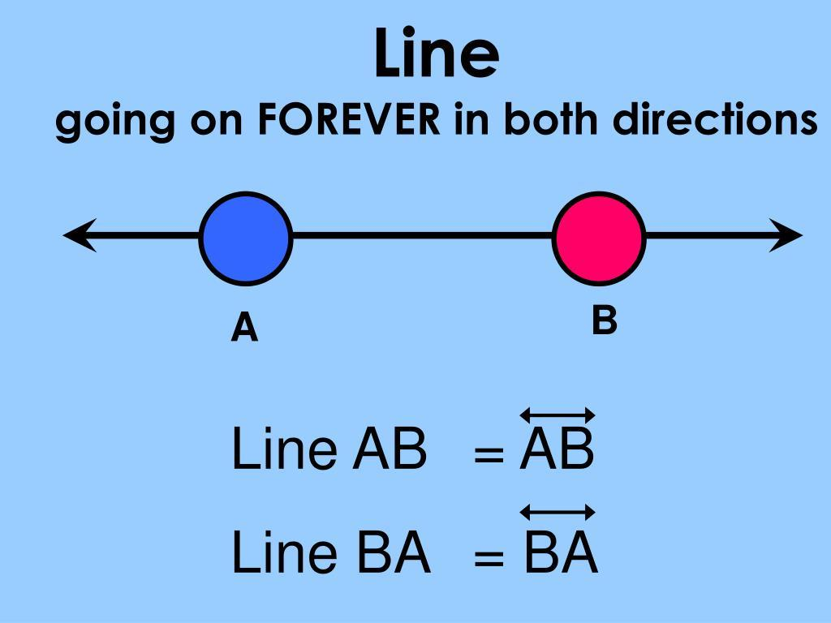
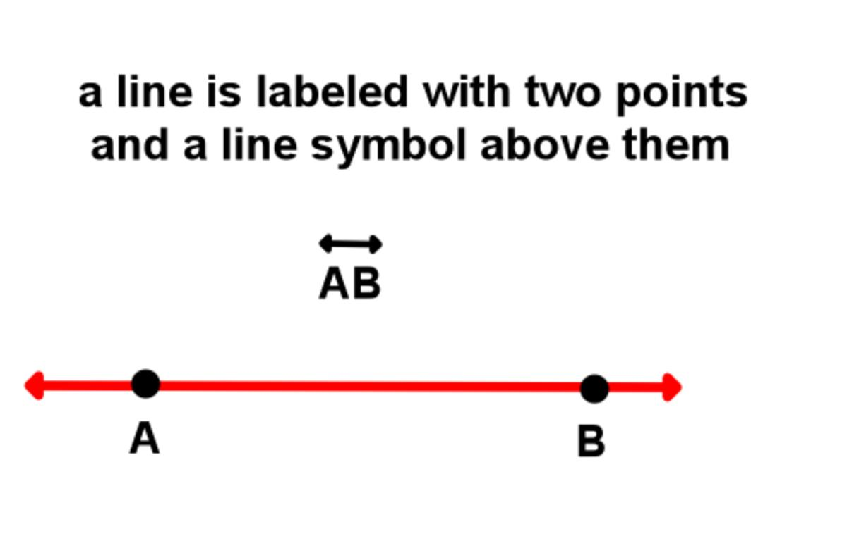

Fundamental Concept
# Source: AI Source: Provided by: [Data Path: Persons Table -> ID Column: 1, Name_En Column: Motasem Essam] -> From: [ChatGPT] on [7/25/2026]
Two distinct points determine exactly one line.
If:
$$A≠B$$
then there is exactly one line passing through both points:
$$\boxed{A,B⇒\overset{↔}{AB}}$$
The straightedge is used to establish the straight direction between the two points.

Basic Construction
# Source: AI Source: Provided by: [Data Path: Persons Table -> ID Column: 1, Name_En Column: Motasem Essam] -> From: [ChatGPT] on [7/25/2026]
Constructing a Line Through Two Given Points
Suppose $A$and $B$are two given points.
Steps
- Mark the two given points $A$and $B$.
- Place the straightedge so that its edge passes through both points.
- Draw a straight line through $A$and $B$.
- Extend the line beyond $A$and beyond $B$.
- Add arrows at both ends to indicate that the line continues indefinitely.
The resulting line is:
$$\boxed{\overset{↔}{AB}}$$
Representation
←────────A────────B────────→
The arrows indicate that the line continues infinitely in both directions.

Constructing a Line From a Given Segment
# Source: AI Source: Provided by: [Data Path: Persons Table -> ID Column: 1, Name_En Column: Motasem Essam] -> From: [ChatGPT] on [7/25/2026]
A line can be constructed by extending a given line segment in both directions.
Given:
$$\overset{‾}{AB}$$
extend the segment beyond both $A$and $B$:
$$\boxed{\overset{↔}{AB}}$$
←────────A────────B────────→
The segment is therefore a finite portion of the resulting line.

Constructing a Line Through a Given Point and Direction
# Source: AI Source: Provided by: [Data Path: Persons Table -> ID Column: 1, Name_En Column: Motasem Essam] -> From: [ChatGPT] on [7/25/2026]
A line can also be constructed when a point $P$and a direction are given.
Steps
- Mark the given point $P$.
- Establish the required direction.
- Choose or construct another point $Q$in that direction.
- Place the straightedge through $P$and $Q$.
- Extend the line in both directions.
The resulting line is:
$$\boxed{\overset{↔}{PQ}}$$

Constructing a Line Through Two Points
# Source: AI Source: Provided by: [Data Path: Persons Table -> ID Column: 1, Name_En Column: Motasem Essam] -> From: [ChatGPT] on [7/25/2026]
This is the fundamental construction because two distinct points uniquely determine a line.
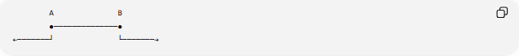
A B
●──────────────●
←───────┘ └───────→
More simply:
←────────●────────●────────→
A B

Types of Line Construction
# Source: AI Source: Provided by: [Data Path: Persons Table -> ID Column: 1, Name_En Column: Motasem Essam] -> From: [ChatGPT] on [7/25/2026]
The construction situations can be organized as follows:
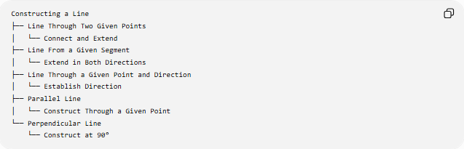
Constructing a Line
├── Line Through Two Given Points
│ └── Connect and Extend
├── Line From a Given Segment
│ └── Extend in Both Directions
├── Line Through a Given Point and Direction
│ └── Establish Direction
├── Parallel Line
│ └── Construct Through a Given Point
└── Perpendicular Line
└── Construct at 90°
Classification note: The first three describe basic ways of constructing a line. Parallel line and perpendicular line are specialized line-construction problems rather than different mathematical types of lines.

Mathematical Representation
# Source: AI Source: Provided by: [Data Path: Persons Table -> ID Column: 1, Name_En Column: Motasem Essam] -> From: [ChatGPT] on [7/25/2026]
A line through $A\left(x_{1} , y_{1}\right)$and $B\left(x_{2} , y_{2}\right)$can be represented by its slope:
$$\boxed{m=\frac{y_{2}-y_{1}}{x_{2}-x_{1}}}$$
when:
$$x_{2}≠x_{1}$$
Its equation can then be written as:
$$\boxed{y-y_{1}=m\left(x-x_{1}\right)}$$
For a vertical line:
$$\boxed{x=x_{1}}$$

Important Properties
# Source: AI Source: Provided by: [Data Path: Persons Table -> ID Column: 1, Name_En Column: Motasem Essam] -> From: [ChatGPT] on [7/25/2026]
1. Two Distinct Points Determine One Line
$$\boxed{A≠B⇒\text{exactly one line through }A\text{ and }B}$$
2. A Line Has No Endpoints
Unlike a segment or ray, a line has no endpoints.
$$\boxed{\text{Endpoints}=0}$$
3. A Line Extends in Both Directions
A line continues infinitely in both directions.
4. A Line Has Infinite Length
A line does not have a finite length.
5. Every Segment on the Line Is Finite
Although the complete line is infinite, any segment between two points on it has a finite length:
$$AB<∞$$

Line vs Segment vs Ray
# Source: AI Source: Provided by: [Data Path: Persons Table -> ID Column: 1, Name_En Column: Motasem Essam] -> From: [ChatGPT] on [7/25/2026]
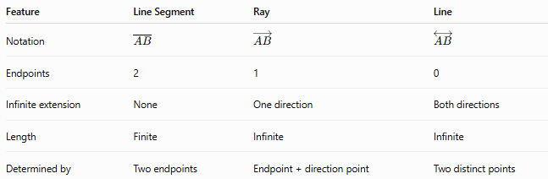
Feature | Line Segment | Ray | Line
Notation | $$\overset{‾}{AB}$$ | $$\vec{AB}$$ | $$\overset{↔}{AB}$$
Endpoints | 2 | 1 | 0
Infinite extension | None | One direction | Both directions
Length | Finite | Infinite | Infinite
Determined by | Two endpoints | Endpoint + direction point | Two distinct points

Visual Comparison
# Source: AI Source: Provided by: [Data Path: Persons Table -> ID Column: 1, Name_En Column: Motasem Essam] -> From: [ChatGPT] on [7/25/2026]
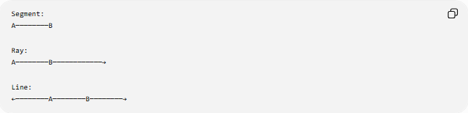
Segment:
A────────B

Ray:
A────────B────────────→

Line:
←────────A────────B────────→

Constructing a Parallel Line
# Source: AI Source: Provided by: [Data Path: Persons Table -> ID Column: 1, Name_En Column: Motasem Essam] -> From: [ChatGPT] on [7/25/2026]
A specialized construction creates a line through a point $P$parallel to a given line $l$:
$$\boxed{m∥l}$$
This can be constructed by copying an angle or by using perpendicular lines.
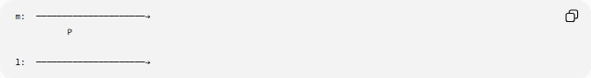
m: ─────────────────────→
P

l: ─────────────────────→

Constructing a Perpendicular Line
# Source: AI Source: Provided by: [Data Path: Persons Table -> ID Column: 1, Name_En Column: Motasem Essam] -> From: [ChatGPT] on [7/25/2026]
A specialized construction creates a line that intersects another line at a right angle:
$$\boxed{m⊥l}$$
Therefore:
$$\boxed{∠\left(m , l\right)={90}^{∘}}$$
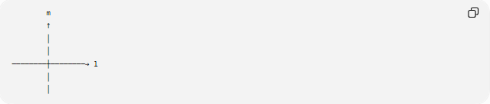
m
↑
│
│
────────┼────────→ l
│
│

Tools Used
# Source: AI Source: Provided by: [Data Path: Persons Table -> ID Column: 1, Name_En Column: Motasem Essam] -> From: [ChatGPT] on [7/25/2026]
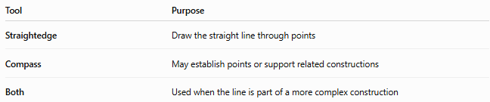
Tool | Purpose
Straightedge | Draw the straight line through points
Compass | May establish points or support related constructions
Both | Used when the line is part of a more complex construction
For the basic construction of a line through two existing points, the straightedge is sufficient.

Relationship to Other Geometric Objects
# Source: AI Source: Provided by: [Data Path: Persons Table -> ID Column: 1, Name_En Column: Motasem Essam] -> From: [ChatGPT] on [7/25/2026]
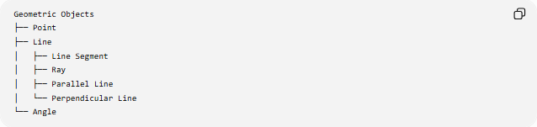
Geometric Objects
├── Point
├── Line
│ ├── Line Segment
│ ├── Ray
│ ├── Parallel Line
│ └── Perpendicular Line
└── Angle
More precisely, a segment and a ray are parts of a line, while parallel and perpendicular describe relationships between lines.

Key Points
# Source: AI Source: Provided by: [Data Path: Persons Table -> ID Column: 1, Name_En Column: Motasem Essam] -> From: [ChatGPT] on [7/25/2026]
- A line is a straight geometric object extending infinitely in both directions.
- A line has no endpoints.
- Two distinct points determine exactly one line.
- The notation for the line through $A$and $B$is:
$$\boxed{\overset{↔}{AB}}$$
- A basic line can be constructed using a straightedge.
- A segment can be extended in both directions to form a line.
- Parallel and perpendicular lines are specialized line-construction problems.
- A line differs from a ray because a ray extends in only one direction.
- A line differs from a segment because a segment has two endpoints and finite length.

Conclusion
# Source: AI Source: Provided by: [Data Path: Persons Table -> ID Column: 1, Name_En Column: Motasem Essam] -> From: [ChatGPT] on [7/25/2026]
Constructing a Line is the process of creating a straight geometric object through two distinct points and extending it infinitely in both directions. The fundamental construction uses a straightedge to connect the two points and extend the line beyond them. Lines provide the foundation for constructing segments, rays, parallel lines, perpendicular lines, angles, and many other geometric objects.

